## Prelim Pages

Version Control /Approval etc

## Introduction

Chapter 3 covers the interface developed in the tool as part of the package to manage and maintain the data sets. Ease of use and accessibility to custom functionality is a paramount consideration.

A custom ribbon ensures the interface is available no matter which sheet the user is dealing with and custom user forms or dialogs enhance the process of managing the data.

Using these features is covered in later relevant chapters.

## Custom Ribbon

Excels’ built in ribbon is extensible and a custom tab with buttons is added to give the user permanent access to the interface. The tab is located on the Excel interface as depicted in Figure 1 below.

### 

Figure

The custom buttons are organised in to functional areas, as seen in Figure 2 below. Each group logically assembles the buttons based on primary functionality.

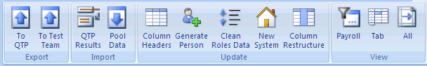

Figure

When these buttons are clicked, they open up other dialogs and begin a process that can be cancelled by the user before the process starts.

### Export

Export sends data from the Spreadsheet out to one of two places, either for QTP or to the test teams. The location for both is customisable and is located on a hidden sheet call “Configuration”.



Figure

### Import

Import gets the data from one of two resources:

* QTP results runtime data table, or
* Opens the Org Structure dialog and generates new data on demand.



Figure

**QTP Results** requires the user to locate the Results Folder (usually names ResX) and locates the actual file itself.

**Pool Data** Org Structure dialog can open a structure file (XML format) and allow further editing and generate new data. Existing data cannot be updated with this tool.

### Update

Update contains a range of useful functions:

* **Columns Headers** is embedded into Column Restructure. It is still available, with the caveat that the user View the ACHire tab (from the View buttons) and apply updates the the column headers before clicking.
* **Generate Person** fills in missing data for people to be hired. Used in conjunction with a Default Data sheet to reduce time spent fixing data tables where hundreds of points require updating.
* **Clean Roles** is used to pick up older invalid codes for security roles embedded throughout the datasets. The source data for this is located on a sheet within the master named Roles.
* **New system** prepares existing data for re-use in a new system or client. Data, such as SAP Object Identifiers (eg 60005142) are removed in the sheet making it ready to export and use in an execution.
* **Column Restructure** Performs the task of re-arranging the columns via a temporary sheet under user control.



Figure

Each of these impacts on the data of the visible sheets. The user is advised to exercise caution and confirm they have got the right payroll before using these.

### View

View enables the user to filter the tabs (or worksheets) by updating their visible property in the master spreadsheet. These are broken down into:

* **Payroll**. Payroll is the formal value used to separate a range of sheets into units of work. The name is a legacy name from the early discussions with the test teams and has evolved to cover a broader meaning. Payrolls have generally been arranged between 60 and 69. Other identifiers, such as Useability and Security are also used to identify a unit of work for records used by both manual and automation.
* **Tab**. The most flexible method is view by tab. We can choose any sheet in the set, including the sheets that support the operation (eg configuration, Default Data). The user may optionally hide all others and/or
* **All**. Cart Blanche render all the valid data set spreadsheets visible (unhide).



Figure

## Custom Forms

### Export

Both export functions ask which data set to export. Users may cancel or pick a row in the list and click OK to proceed.

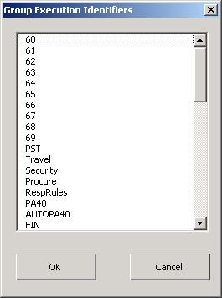

Figure

Export to Test Teams displays an additional dialog after Figure 7 above to choose a raw (all) or formatted (Testers) output.

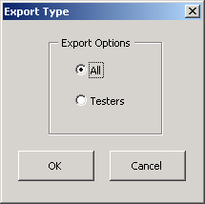

Figure

See Chapter 5 for more detail on Exporting data.

### Import

**QTP Results**. The standard windows Folder Browser is used to locate the QTP results folder (not the file). The program can locate the file without further refinement.

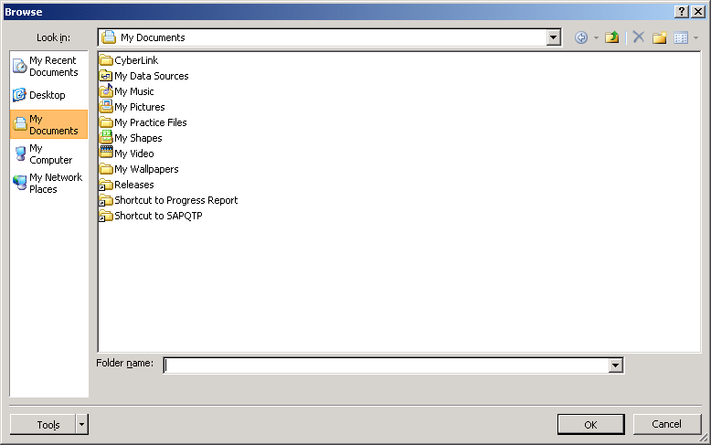

Figure

See Chapter 5 for more detail on Importing data.

**Pool Data.** The buttons displays this custom form for the user to either open an existing XML file or to create a custom structure.

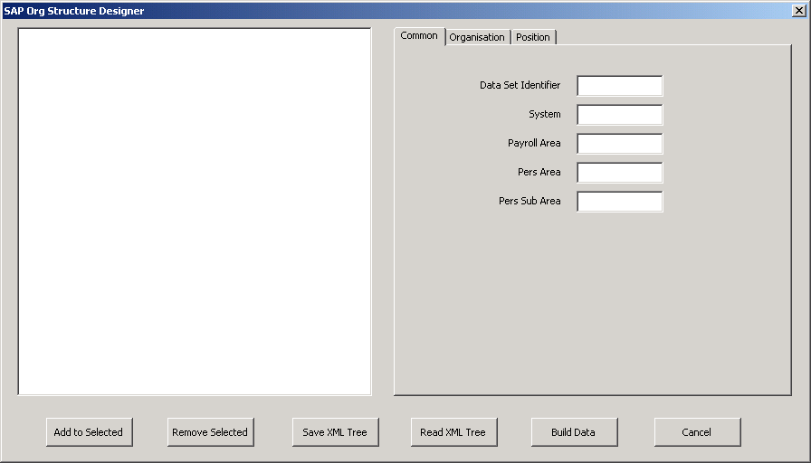

Figure

Figure 10 dialog above presents the user with Figure 11 dialog below for each node in the tree to collect data specific to the node. Further, Figure 11 dialog below can present the user with Figure 12 below when the dyadic (...) button is clicked.

|  |  |
| --- | --- |
| Figure | Figure |

See Chapter 4 for more detail on this custom interface.

### Update

**Column Headers**, **Generate Person**, **Clean Roles** and **New system** do not have a dialog or form for the user to interact with.

**Column Restructure** initially copies data over to a temporary spreadsheet followed by Figure 13 below. The dialog allows the user to move, add and delete complete columns in the data sets.

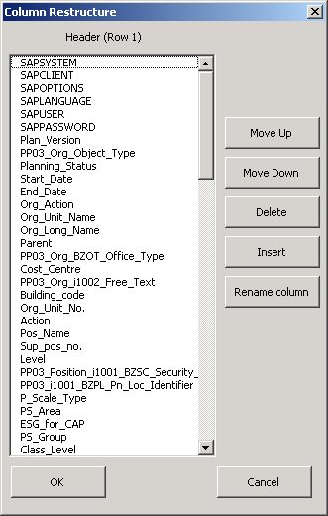

Figure

When a new column is added, the user can change the headers colour to assist with quick identification of the columns purpose, eg Value extracted from target system.

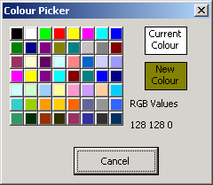

**Figure 14**

See Chapter 8 for more detail on restructuring data columns.

### View

View provides the ability to filter the sheets in the master spreadsheet by payroll or by sheet name. The dialogs in Figure 15 and Figure 16 below allow a user to focus on a specific payroll or a specific tab.



Figure

Tab List in Figure 16 below is based on the names given by either the spreadsheet (eg Sheet 1) or by the user (eg ACHire). The extra features of this dialog enhance its usage by including the ability to hide the rest and/or activate the sheet.

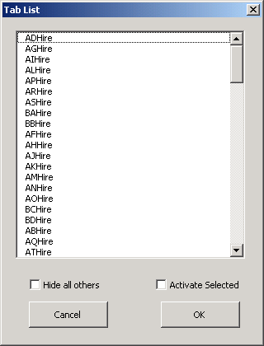

Figure

...oooOOOooo...